Annual NHS R&D Forum Conference

Top 10 Reasons to attend

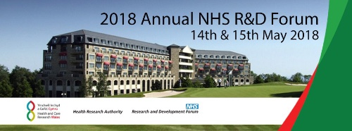

- To build relationships, create opportunities and make new connections with over 500 research management professionals, research support and delivery staff, research leaders, patients, service users, policy makers, regulators, charities and industry representatives from across the UK. This year we have extended our connecting opportunities with a Sunday night professional networking event and 5 topic-specific fringe events.

- To discuss developments in current practice and to discover new initiatives being driven by R&D departments to improve health & care through good research management and support services in the UK. We have accepted over 50 poster presentations and more than 50 speakers this year, all of them will be available to answers questions at the event.

- To hear the latest developments in research policy from leaders in health, science and innovation, and from speakers who are right at the forefront of developments in the NHS and the national research landscape.

- To learn from experts in 1 of 5 Monday morning workshops and current hot topics

- To have an opportunity to share your expertise and showcase your innovative solutions to everyday challenges as well as those new topics that are on the horizon.

- To learn from all parts of the community and ask questions of regulators, policy makers, partners and peers, in small groups and over coffee and at the exhibition. Feedback last year highlighted the value in sharing coffee with regulators and those in policy roles.

- To source additional opportunities for external services and support from those organisations who are sponsoring the annual forum.

- To grow research. If you are from industry, a University, a funding organisation, or a non-NHS/health care setting you will have the opportunity to meet with hundreds of staff who are running, supporting and leading research on a daily basis. Learn how we do it and create many opportunities for research growth.

- To learn more about the NHS R&D Forum community and how you can get involved.

- To make a difference to what we do together

The Professional Network for Research Management, Support & Leadership in Health & Care

Leading, promoting, shaping & influencing quality health research

