Research policy and procedures

Version:
Name of originator/author:
Name of executive lead:
Date ratified:
Review date:
APPLICABLE TO:
All staff.
EXECUTIVE SUMMARY
The purpose of this research policy and procedures document (Hereinafter called “the document”) is to ensure that <ORGANISATION’S NAME> complies with the principles set out in the UK Policy Framework for Health and Social Care Research (Hereinafter called “the policy framework”), thus ensuring the quality, safety, and good conduct of all research activity led or hosted by <ORGANISATION’S NAME>.
This policy and procedures document describes the organisational and individual responsibilities, and the relevant procedures, which are necessary to support research activities within <ORGANISATION’S NAME>.
IMPLEMENTATION
Key points for implementation by managers are to ensure that:

- all proposed research involving either <ORGANISATION’S NAME> staff or patients/service users complies with the policy framework;

- research studies are registered with <ORGANISATION’S NAME> and do not proceed without explicit written approval of the <ORGANISATION’S NAME>.

This document can only be considered valid when viewed via the <ORGANISATION’S NAME>’s intranet site. If this document is printed into hard copy or saved to another location you must check that the version number on your copy matches that of the one on-line. The document applies to full and part time employees, bank and agency employees.

CONSULTATION PROCESS

Key individuals involved in developing this document (main authors)

Name | Designation

Circulated to the following individuals for consultation

Name | Designation

Circulated to the following groups for ratification

Name of Group | Date

VERSION CONTROL

Version No | Updated By | Updated On | Description of Changes

CONTENTS

Section |  |  | Page
 | Consultation process |  | 2
 | Contents |  | 3
A | 1. Introduction |  | 4
 | 2. Definitions |  | 4
 | 3. Aims and Objectives |  | 4
 | 4. Responsibilities |  | 4
 | 5. Approvals |  | 5
 | 6. Resources |  | 5
 | 7. Indemnity |  | 6
 | 7.1 | <ORGANISATION’S NAME> initiated | 6
 | 7.2 | Externally initiated | 6
 | 8. Dissemination |  | 6
B | 9. Procedure |  | 7
 | i. For Non-Commercial (Academic) Research |  | 7
 | ii. For Commercial Research |  | 8
Appendices
1 | UK Policy Framework for Health and Social Care Research |  | 11
2 | Defining research |  | 13
3 | Research Approval Flowchart for Non-Commercial (Academic) Research |  | 14
4 | Research Approval Flowchart for Commercial Research |  | 15
Section A: Policy

- Introduction

<ORGANISATION’S NAME> promotes, supports and encourages the conduct of high quality research and the use of research evidence to inform practice. It also encourages relevant training to create a workforce able to contribute to research in health and social care and to make use of research evidence appropriately.

In October 2017 the Health Research Authority (HRA&HCRW) and the health departments in Northern Ireland, Scotland and Wales published the UK Policy Framework for Health and Social Care Research, which replaced the Government’s Research Governance Framework 2nd Edition. The policy framework sets out 19 principles of good practice in the management and conduct of health and social care research in the UK that take account of legal requirements and other standards.

The purpose of this document is to ensure that <ORGANISATION’S NAME> complies with the principles as set out in the policy framework, thus ensuring the quality, safety, and good conduct of all research activity led or hosted by <ORGANISATION’S NAME>; and that the dignity, rights, safety and well-being of research participants are protected.

- Definitions

Research may be defined as the attempt to derive generalisable or transferable new knowledge to answer or refine relevant questions with scientifically sounds methods. This excludes activities such as clinical audit and patient satisfaction surveys which are concerned with evaluating local service planning and delivery against evidence based standards. If in doubt as to whether a planned activity constitutes research and therefore falls within the terms of this document advice should be sought from Bath Research and Development (BRD).

Aims and Objectives

The aim of this document is to ensure that all research conducted within <ORGANISATION’S NAME> is compliant with the relevant legal and governance requirements, and, where necessary, meets ethical standards. To ensure this is achieved, this document:
- Sets out <ORGANISATION’S NAME> organisational responsibilities.
- Sets out the responsibilities of researchers.
- Describes the procedures that researchers are required to follow to obtain governance and legal compliance approval from <ORGANISATION’S NAME>.

Responsibilities

Research and Development (R&D) in <ORGANISATION’S NAME> is overseen by the <R&D LEAD NAME>.

The strategic direction for R&D as set out in Best Research for Best Health (Department of Health, 2006) and implemented by Bath Research and Development (BRD). BRD is a partnership that was formed in April 2005 between the Department for Health, University of Bath and BaNES, Swindon and Wiltshire Clinical Commissioning Groups. BRD currently receives funding from the Department of Health to support high quality research. This money is spent on supporting NIHR research and sustaining a research workforce. It offers a research management and governance support service to local researchers.

This document is potentially relevant to all members of staff. Even staff who are not directly involved in the conduct of research may have responsibilities if they are providing clinical care to patients enrolled into research studies. This document applies to all research, whether it is initiated by an employee of <ORGANISATION’S NAME> as the principal investigator (i.e. <ORGANISATION’S NAME> is the investigator site) or the employee is participating in research led from elsewhere.

It is the responsibility of researchers to be familiar with research standards and guidance and to comply with all legal requirements and those of the Department of Health.

Approvals

All proposed research involving patients, patient data, staff or facilities of <ORGANISATION’S NAME> or its provider organisations must comply with the policy framework. Research studies must be registered with <ORGANISATION’S NAME> and cannot proceed without explicit written approval of the <R&D LEAD NAME> or his / her nominated deputy, confirming that the research complies with the relevant legal and governance requirements. In addition, where a research ethics committee (REC) review is required, a favourable opinion must be received before the study can commence. Guidance on obtaining REC favourable opinion is available at www.hra.nhs.uk. RECs give an opinion about proposed participant involvement and whether the research is ethical. Approval issued by <ORGANISATION’S NAME> considers the wider issues of scientific quality, financial arrangements, data protection, medicines management issues and legal compliance. The research review procedure is detailed in Section B.

If <ORGANISATION’S NAME> staff are approached by researchers requesting information regarding patients they have a responsibility to check with the Information Governance Manager or the Research Governance Lead to confirm whether the research study has been ethically approved and that the flow of information requested is in line with the research protocol.

Resources

Research should not be undertaken without identification of the resource requirements and the sources to be used for provision of those resources. The funding arrangements for the study must be explicit, agreed by all relevant parties and seen to offer the taxpayer value for money. There are four basic types of cost:

- Research costs specifically associated with the running of the study (including staff appointed expressly for the purpose of the study).
- Service support costs – additional patient care costs which will end when the study’s complete (e.g. extra blood tests).
- Excess treatment costs – the extra cost of a new intervention or service under investigation compared with current practice.
- Indirect costs – infrastructure and general overheads

Staff engaged in research other than within the terms of their contract of employment should ensure that such involvement is not to the detriment of their clinical or other contractual workload. The written approval of their line manager needs to be secured for their participation in research activity and a copy of this approval provided as part of the research approval application. Where the research may affect routine clinical sessions appropriate cover needs to be secured and funding provided for this.

If there are any resource implications for any department arising from a study these should be made known to the department(s) and financial agreements made where necessary and detailed as part of the application research approval application.

For commercial studies all costs must be met by the sponsor company. A levy is raised by <ORGANISATION’S NAME> for hosting commercial research to cover infrastructure and overhead costs.

Indemnity

7.1 <ORGANISATION’S NAME> initiated:
- Service improvement activity (not research) – talking to service users about experience of care and ways to improve it.
- Research – non drug related research. Mainly about evaluation of new models of care or components of care via assessment tools (questionnaires, assessments)

Indemnity/Insurance cover: this is not covered under <ORGANISATION’S NAME>’s existing insurance policies but can be added on a case by case basis. The <ORGANISATION’S NAME> must be contacted to arrange cover prior to approval and will be able to provide copies of the insurance certificates if required.

7.2 Externally initiated – i.e. other organisations, universities predominantly wanting to use our clients/services for evaluation;
- Research – where another organisation is acting as sponsor for the research, they will have their own insurance for the study (this is checked as part of the governance checks before we agree to participate in any studies). In these situations the research is usually undertaken by research study staff covered by said insurance. <ORGANISATION’S NAME> staffs input is minimal usually i.e. identifying potential service users to participate, completing some forms etc.

Indemnity/Insurance cover: this is not included under <ORGANISATION’S NAME>’s insurance policies. Therefore staff must liaise with the <ORGANISATION’S NAME> and <R&D LEAD NAME> prior to submitting a research approval application to discuss insurance and indemnity for this work.

All commercially sponsored pharmaceutical related studies must provide the standard indemnity conforming to the most recent guidelines of the Association of the British Pharmaceutical Industry, a signed copy of the indemnity agreement should be submitted with the application to the local ethics committee. Bath Research and Development will also need to see evidence of this ABPI standard indemnity.

For NHS-sponsored research, Health and Safety guidance HSG (96)48 applies. Both sponsors and investigators must have insurance or indemnity cover to meet their potential liabilities arising from research. Under the UK Policy Framework for Health and Social Care Research, the research sponsor is responsible for ensuring that appropriate insurance and indemnity are in place for the research. This includes ensuring that research participants who are receiving NHS-funded care are covered by NHS indemnity in respect of negligent harm.

- Dissemination

Appropriate details of ongoing research should be made available to relevant research registers. Randomised trials should be registered on an appropriate trials register.

The results of a study should be made widely available in an accessible form to all those with the potential to derive benefit, including patients, carers and healthcare professionals. This normally includes publication in peer-reviewed journals and presentations at national and international meetings. There should be particular attention paid to making the research results known to research participants, and innovative approaches to reaching this audience should be pursued, e.g. publications in patient groups’ newsletters, presentations to patient groups etc.

Section B: Procedure

- Procedure

The following procedure has been developed in conjunction with the BRD to facilitate efficient review and approval of research studies with regards to research governance. Flow charts illustrating these procedures are shown in Appendices 2 and 3.

NOTE:
- <ORGANISATION’S NAME> is classed as a non-NHS organisation commissioned to provide NHS Services.
- Research studies involving the NHS (organisations, patients, data and staff) are approved via a centralised service - HRA&HCRW Approval - and a coordinated REC review (if required), which comprises a single, combined Integrated Research Application System (IRAS: https://www.myresearchproject.org.uk/) form and study document set that are submitted electronically.

9.1 FOR NON-COMMERCIAL (ACADEMIC) WORK

The PI or member of research team contacts the relevant lead at <ORGANISATION’S NAME> to discuss the study and to determine if <ORGANISATION’S NAME> would like to be a participating organisation.

If <ORGANISATION’S NAME> agree to be a participating organisation then one of the following processes should be followed when applying for approval:

- If the study also involves NHS sites then it will require HRA&HCRW Approval. <ORGANISATION’S NAME> should be identified in Part C of the IRAS form as a non-NHS Site. If the study requires NHS REC review then a non-NHS Site Assessment Form (SAF) may be required as part of the NHS REC review, for guidance visit: https://www.myresearchproject.org.uk/help/hlpsitespecific.aspx#non-NHS-sites. The NHS REC will assess the suitability of the site and PI as part of the full REC review

- If the study only involves <ORGANISATION’S NAME>, as they are classed as a non-NHS Site then HRA&HCRW Approval would not be required but the study may still require NHS REC review (see: http://www.hra-decisiontools.org.uk/ethics/). If the study does require NHS REC review then follow process 1 for completing the IRAS form.

- If the study only involves <ORGANISATION’S NAME> and does not require NHS REC review - the study will be reviewed internally by the <R&D LEAD NAME> with support from BRD.

If process 1 or 2 is followed, once the IRAS form has been submitted, and the relevant approvals received, the researcher should send these along with the full study document set (including the IRAS form and non-NHS SAF – if completed) to BRD.

Upon receipt, BRD will review the study document set to ensure it is complete and correct, and, if HRA&HCRW Approval was not required, undertake research governance and legal compliance assessment.

Following the assessment, a study brief is prepared and sent to the <R&D LEAD NAME> for internal review, along with relevant study documents and the review form (RF) highlighting any issues of note.

Once a satisfactory internal review has been conducted, and any issues raised discussed and resolved with the CI, the <R&D LEAD NAME> or his / her nominated deputy will notify BRD that the study is approved.

Once BRD are notified that the study has received approval, an email (and letter - if full assessment completed) will be issued assuring the CI/research team that the study meets the required research governance and legal compliance criteria. The letter is copied to the <R&D LEAD NAME>.

The PI will liaise with <ORGANISATION’S NAME> to confirm they have the capacity and capability to conduct the study, and to agree the study contract including any associated costs.

9.2 FOR COMMERCIAL RESEARCH

The Sponsor Study Coordinator contacts the relevant lead at <ORGANISATION’S NAME> to discuss the study and to determine if <ORGANISATION’S NAME> would like to be a participating organisation.

If <ORGANISATION’S NAME> agree to be a participating organisation then one of the following processes should be followed when applying for approval:

- If the study also involves NHS sites then it will require HRA&HCRW Approval. <ORGANISATION’S NAME> should be identified in Part C of the IRAS form as a non-NHS Site. If the study requires NHS REC review then a non-NHS Site Assessment Form (SAF) may be required as part of the NHS REC review, for guidance visit: https://www.myresearchproject.org.uk/help/hlpsitespecific.aspx#non-NHS-sites. The NHS REC will assess the suitability of the site and PI as part of the full REC review

- If the study only involves <ORGANISATION’S NAME>, as they are classed as a non-NHS Site then HRA&HCRW Approval would not be required but the study may still require NHS REC review (see: http://www.hra-decisiontools.org.uk/ethics/). If the study does require NHS REC review then follow process 1 for completing the IRAS form.

- If the study only involves <ORGANISATION’S NAME> and does not require NHS REC review - the study will be reviewed internally by the <R&D LEAD NAME> with support from BRD.

If process 1 or 2 is followed, once the IRAS form has been submitted, and the relevant approvals received, the Sponsor Study Coordinator should send these along with the full study document set (including the IRAS form and non-NHS SAF – if completed) to BRD.

Upon receipt, BRD will review the study document set to ensure it is complete and correct, and, if HRA&HCRW Approval was not required, undertake research governance and legal compliance assessment..

Following the assessment, a study brief is prepared and sent to the <R&D LEAD NAME> for internal review, along with relevant study documents and the review form (RF) highlighting any issues of note.

Once a satisfactory internal review has been conducted, and any issues raised discussed and resolved with the Sponsor Study Coordinator, the <R&D LEAD NAME> or his / her nominated deputy will notify BRD that the study is approved.

Once BRD are notified that the study has received approval, an email (and letter - if full assessment completed) will be issued assuring the Sponsor Study Coordinator team that the study meets the required research governance and legal compliance criteria. The letter is copied to the <R&D LEAD NAME>.

The Sponsor Study Coordinator will liaise with <ORGANISATION’S NAME> to confirm they have the capacity and capability to conduct the study, and to agree the study contract including any associated costs.

Appendix 1

UK Policy Framework for Health and Social Care Research

The purpose of the policy framework is:
- To protect and promote the interests of patients, service users and the public in health and social care research, by describing ethical conduct and proportionate, assurance-based management of health and social care research, so as to support and facilitate high-quality research in the UK that has the confidence of patients, service users and the public.
- To ensure a consistent approach to coordinating and standardising regulatory practice, and achieve compatibility across the UK for the management and conduct of health and social care research.

The policy framework sets out 19 principles of good practice in the management and conduct of health and social care research that take account of legal requirements and other standards. The principles are summarised below:

- Safety - of the individual prevail over the interests of science and society.

- Competence - of all the people involved in managing and conducting a research study.

- Scientific and Ethical Conduct - prevails in all aspects of research studies.

- Patient, Service User and Public Involvement - in the design, management, conduct and dissemination of research, unless otherwise justified.

- Integrity, Quality and Transparency - when designing, reviewing, managing and conducting research.

- Protocol - clearly describes and justifies the design and procedure of the research.

- Legality - researchers and sponsors should be familiar with relevant legislation and guidance.

- Benefits and Risks - for the individual participant and other present and future recipients should be assessed before the research study is started.

- Approval - should be gained from a research ethics committee and any other relevant approval body where it is expected or required.

- Information about the Research - is made publicly available before the research study starts.

- Accessible Findings - whether positive or negative, are made accessible, in a timely manner and, where appropriate, in a suitable format for those who took part.

- Choice - research participants are afforded respect and autonomy, taking account of their capacity to understand, and consent is voluntary and informed.

- Insurance and Indemnity - to cover liabilities which may arise in relation to the design, management and conduct of the research study.

- Respect for Privacy - information collected for or as part of the research study is recorded, handled and stored appropriately, while the confidentiality of individual research participants remains protected.

- Compliance - sanctions for non-compliance with these principles will be imposed.

- Justified Intervention - the intended deviation from normal treatment, care or other services is adequately supported by the available information.

- Ongoing Provision of Treatment - the research proposal or protocol and the participant information sheet explains what happens after the research intervention period has ended.

- Integrity of the Care Record - information about treatment, care or other services provided as part of the research study is recorded, handled and stored appropriately and can be understood by others involved in the participant’s care.

- Duty of Care - continues to apply when patients and service users take part in research. If an unmanageable conflict arises between research and patient interests, the duty to the participant as a patient prevails.

Find out more and download a copy of UK Policy Framework for Health and Social Care Research here.

Appendix 2

Defining research

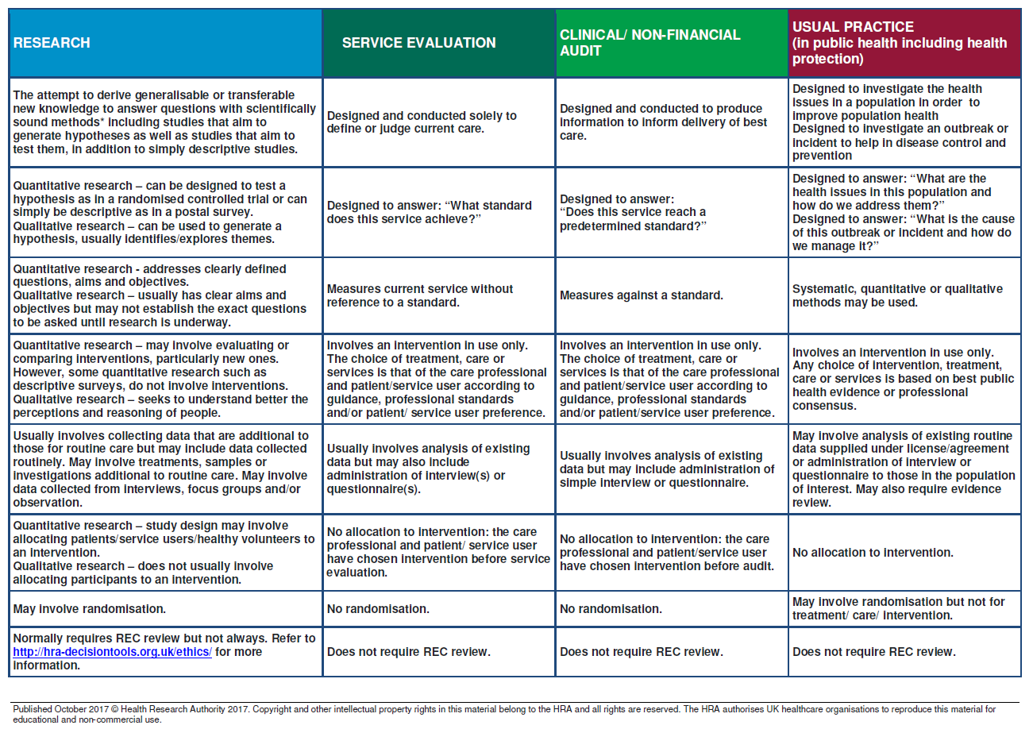

Appendix 3

Non-Commercial (Academic) Research Approval Flowchart

The PI or member of research team contacts the relevant lead at <ORGANISATION’S NAME> to discuss the study and to determine if <ORGANISATION’S NAME> would like to be a participating organisation.

If <ORGANISATION’S NAME> agree, then Principal Investigator (PI) and/or research team either:
- Apply for HRA&HCRW Approval, if there are NHS organisations involved, and if required, REC review.
- Apply for REC review, if required, but not HRA&HCRW Approval if there are no NHS organisations involved.
- Apply for internal review by <ORGANISATION’S NAME> if neither HRA&HCRW Approval nor REC review is required.

For those studies that require HRA&HCRW Approval, the HRA will complete an assessment of governance and legal compliance, and issue an approval letter to the PI.

For those studies that required REC review, on completion of a satisfactory review the REC will issue a favourable opinion letter to the PI.

The PI sends the HRA&HCRW Approval and/or REC favourable opinion letter, plus study document set to BRD (including the IRAS form & non-NHS SAF – if completed).

BRD reviews the study documents and, for studies that did not require HRA Approval, completes an assessment for governance and legal compliance. Upon completion, BRD issue an assurance email (and letter - if full assessment completed) to the PI. The letter is copied to <R&D LEAD NAME>.

The PI will liaise with <ORGANISATION’S NAME> to confirm they have the capacity and capability to conduct the study, and agree the study contract including any associated costs.

Study starts

Appendix 4

Commercial Research Approval Flowchart

The Sponsor Study Coordinator contacts the relevant lead at <ORGANISATION’S NAME> to discuss the study and to determine if <ORGANISATION’S NAME> would like to be a participating organisation.

If <ORGANISATION’S NAME> agree, then Sponsor Study Coordinator either:
- Apply for HRA&HCRW Approval, if there are NHS organisations involved, and if required, REC review.
- Apply for REC review, if required, but not HRA&HCRW Approval if there are no NHS organisations involved.
- Apply for internal review by <ORGANISATION’S NAME> if neither HRA&HCRW Approval nor REC review is required.

For those studies that require HRA&HCRW Approval, the HRA will complete an assessment of governance and legal compliance, and issue an approval letter to the Sponsor Study Coordinator.

For those studies that required REC review, on completion of a satisfactory review the REC will issue a favourable opinion letter to the Sponsor Study Coordinator.

The Sponsor Study Coordinator sends the HRA&HCRW Approval and/or REC favourable opinion letter, plus study document set to BRD (including the IRAS form & non-NHS SAF – if completed).

BRD reviews the study documents and, for studies that did not require HRA Approval, completes an assessment for governance and legal compliance. Upon completion, BRD issue an assurance email (and letter - if full assessment completed) to the Sponsor Study Coordinator. The letter is copied to <R&D LEAD NAME>.

The Sponsor Study Coordinator will liaise with <ORGANISATION’S NAME> to confirm they have the capacity and capability to conduct the study, and to agree the study contract including any associated costs.

Study starts

